School of Engineering

Christian Brothers University

**Invoice and Inventory Management System**

The Engineering Management Capstone Project

Submitted in Partial Fulfillment for the Degree of Master of Science in Computer Information Systems

By:

**Mohammed Yaqoob**

**Bala Rama Krishna Peddi**

Memphis, Tennessee

March 17, 2023

**TABLE OF CONTENTS**

CHAPTER NO**. Invoice and Inventory Management**

1. Abstract ………………………………………………….
2. Introduction ………………………………………………
3. Scope ………………………………………………
4. Problem statement …………………………………
5. Solution to overcome the problem ……………….
6. Technologies Used ………………………………………
7. Project Features ………………………………….............
8. Cover Page …………………………………………
9. Navigation bar for cover page …………………….
10. Home …………………………………………
11. Login page ……………………………………
12. Users Registration page ………………………
13. Contact Us page ………………………………
14. About Us ……………………………………...
15. Navigation bar for Admin ………………………….
16. Home Page…………………………………….
17. View Users ……………………………………
18. Add Product ………………………………….
19. Product List …………………………………...
20. Add stock …………………………………….
21. View stock ……………………………………
22. Logout Functionality …………………………
23. Navigation bar for Users ……………………………
24. Home Page ……………………………………
25. View Profile ………………………………….
26. Change Password …………………………….
27. Logout Functionality ………………………….
28. Output Screenshots ……………………………………….
29. Future ………………………………………………...
    * + - 1. **ABSTRACT**

This project is aimed at developing a desktop-based application named Invoice and Inventory Management System for managing the inventory system of any organization. The Invoice and Inventory Management System refers to the system and process to manage the stock of organization with the involvement of Technology system. This system can be used to store the details of the inventory, stock maintenance, update the inventory based on the sales details, stock, and inventory report. In this application we are solving different problem affecting to direct sales management and purchase management. Invoice and Inventory Management System is important to ensure quality control in businesses that handle transactions resolving around consumer goods. Without proper inventory control, a retail store or wholesale store may run out of stock on an important item. A good inventory management system will alert the retailer or wholesaler when it is running out of stock. Invoice and Inventory Management System is also an important means of automatically tracking stock details. An automated Inventory Management System helps to minimize the problems while running the business.

# 1.INTRODUCTION

The project Invoice and Inventory Management System is a complete desktop-based application designed on Java Technology using Eclipse IDE. The main aim of the project is to develop Invoice and Inventory Management System Model software in which all the information regarding the stock of the organization. This desktop application is based on the management of the stock of an organization. The application contains a general organization profile, sales details, purchase details and the remaining stock that is available in the organization. There is provision for updating the inventory also. This application also provides the information of remaining balance of the stock. Here the login page is created in order to protect the management of the stock of the organization from the misuse of the inventory.

1. **SCOPE:**

Invoice and Inventory Management System (IIMS) is targeted to the small or medium organization which doesn’t have many warehouses i.e., only to those organization that has single power of authority or only one person is responsible in assigning the details or records.

1. **PROBLEM STATEMENT:**

The main problem we observe in small scale organizations is when a customer’s comes to the shop and asked for a product, the salesman go and search for the product. In this process time is being taken more. To avoid this problem, we will add a functionality to search for a particular product in the application and check how much of the stock is left out for the product. This will save time for both customer and the salesman. This kind of problem generally occurs in small scale business organizations. Large scale business organization maintain the inventory, so they don’t get into this problems. So, our application is mainly for small scale organizations.

# 3.TECHNOLOGIES USED

In this application we are using JAVA language for business logic. For frontend development we have used HTML, CSS, JAVASCRIPT languages. And we have used MYSQL database for storage of the data of application. We have used the above-mentioned languages for development of the application. Later we may add the languages as per the requirements.

# 2.PROJECT FEATURES

1. Cover Page:

In Cover Page of our project, we have added a navigation bar. In this navigation bar we can access Home Page, Login Page, User Registrations Page, Contact Us Page and About Us page. We can see the cover page screenshot in Figure 1.1 in Screenshots content.

1. Navigation bar for Cover Page:
2. Home Page: As for now we haven’t added anything to the Home page, In future we may add functionalities based on our project requirements.
3. Login Page: In this login page we can login with admin credentials by selecting admin oqr other user credentials by selecting users. We can see the screen shot of login page in figure 2.1 in Screenshots content.
4. Users Registration Page: In this page we have added a registration form where a user can register by filling up the form. We can see the screen shot of User registration page screenshot in figure 2.2.
5. Contact Us page: This page contains the information to contact us. We have added the address, contact numbers, email ids and address location map. We can see the screen shot of contact us page in figure 2.3.
6. About Us page: In this page we have added the information of the project’s members. We can see the screen shot of about us page in figure 2.4.
7. **Navigation bar for admin:**
8. Home Page: As for now we haven’t added anything to the home page, In future we may add functionalities based on our project requirements. We can see the screen shot of admin home page in Figure 3.1.
9. View Users: In this page we can accept the request of the user when a user registers from registration page. We can also see how many users registered to this application.
10. Add Product: In this functionality we have added a form to add products. By filling the form with necessary details, we can add products to the inventory. We can see the screen shot of add product form in figure 3.2.
11. Product List: This option allows us to view the list of products added to the inventory. We can see the screen shot of product list in figure 3.3.
12. Add Stock: This functionality is added to add the quantity of a particular product to the inventory. As the stock arrives, we can add the quantity of each product with this functionality. We can see the screen shot of add stock form in figure 3.4.
13. View Stock: This option allows us to view how much stock is available in the store. We can check the quantity of the product with this functionality.
14. Logout Functionality: With the logout functionality we can logout from admin.
15. **Navigation bar for Users:**
16. Home Page: As for now we haven’t added anything to the home page, in future we may add functionalities based on our project requirements. We can see the screen shot of User home page in figure 4.1.
17. View Profile: In this functionality user can view the profile of himself. This is just to view the user profile. We can see the screen shot of user profile in figure 4.2.
18. Change password: In this functionality we can change the password for the user. We can see the screen shot of change password functionality in figure 4.3.
19. Logout functionality: With this functionality we can logout of the user.

# 2.OUTPUT SCREENSHOTS

Figure 1.1:

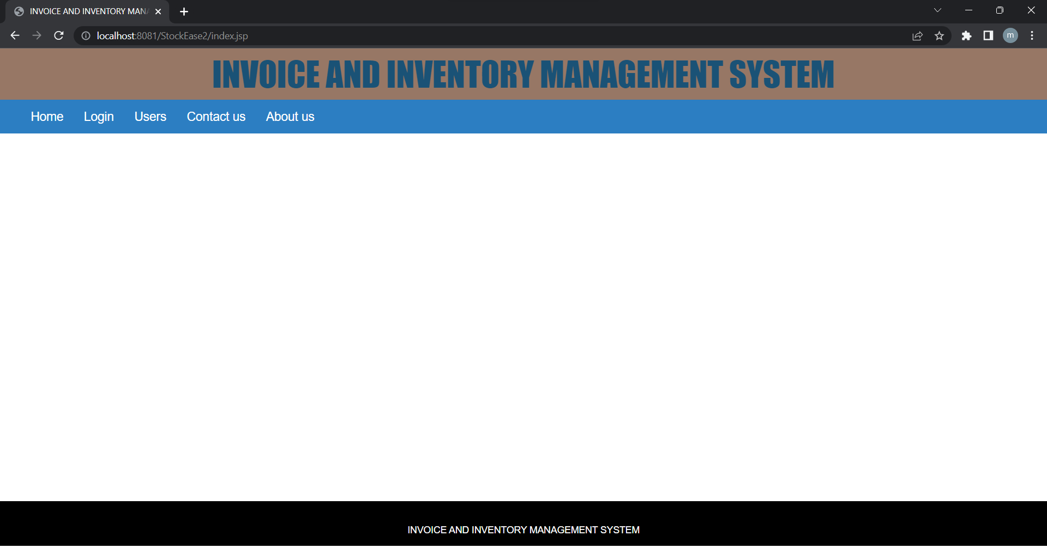

Figure 2.1: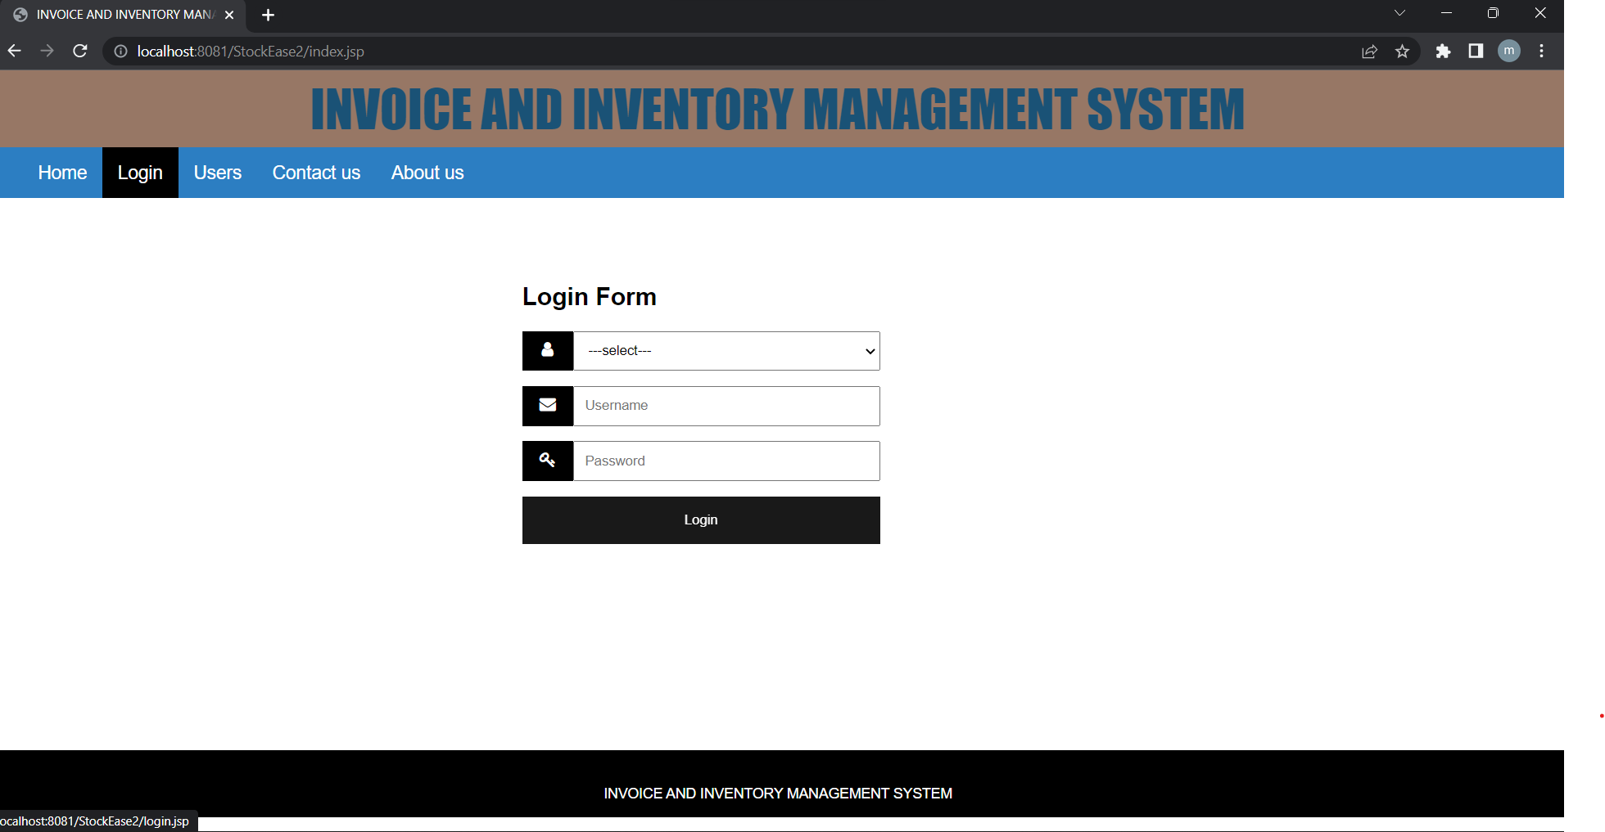

Figure 2.2:

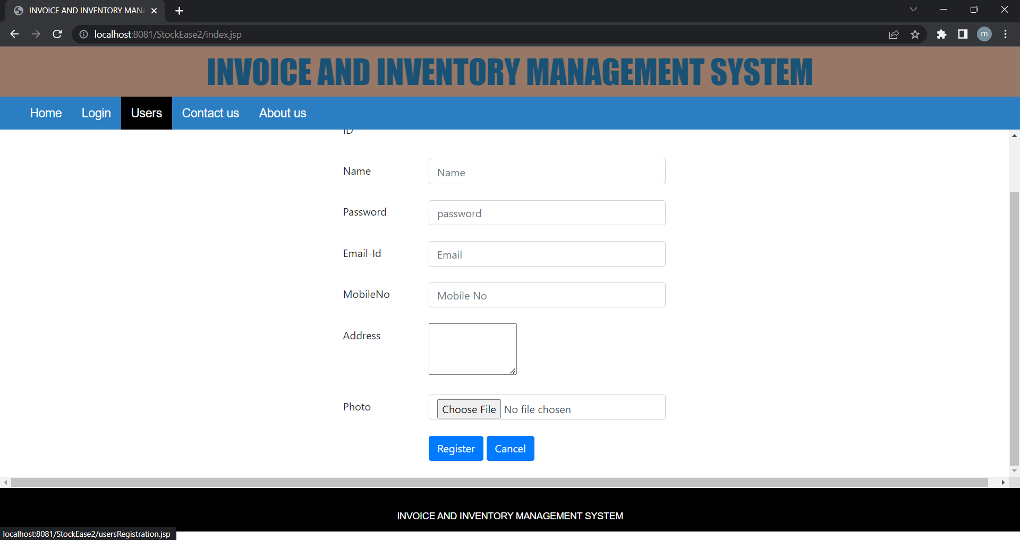

Figure 2.3:

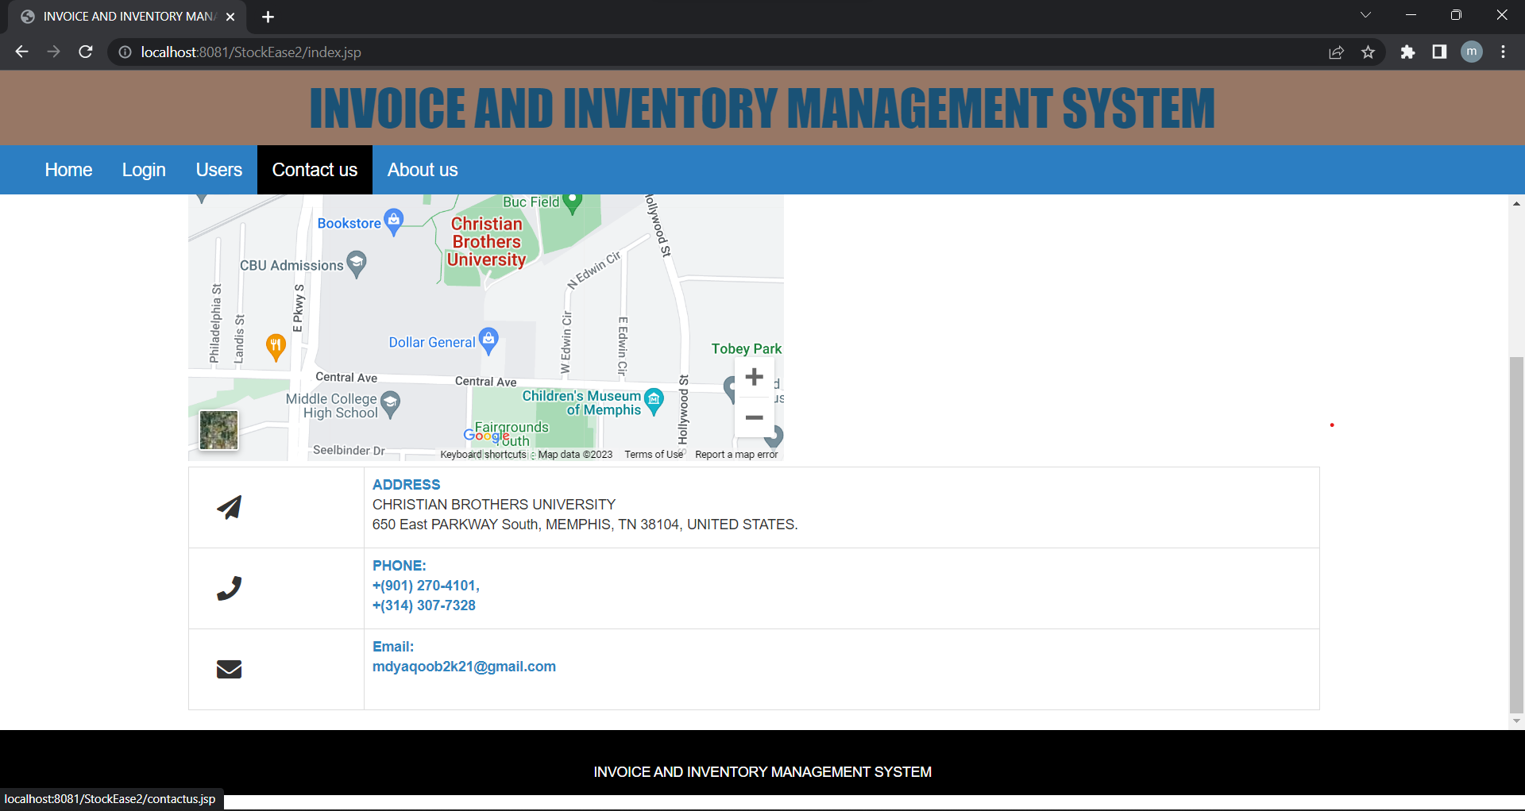

Figure 2.4:

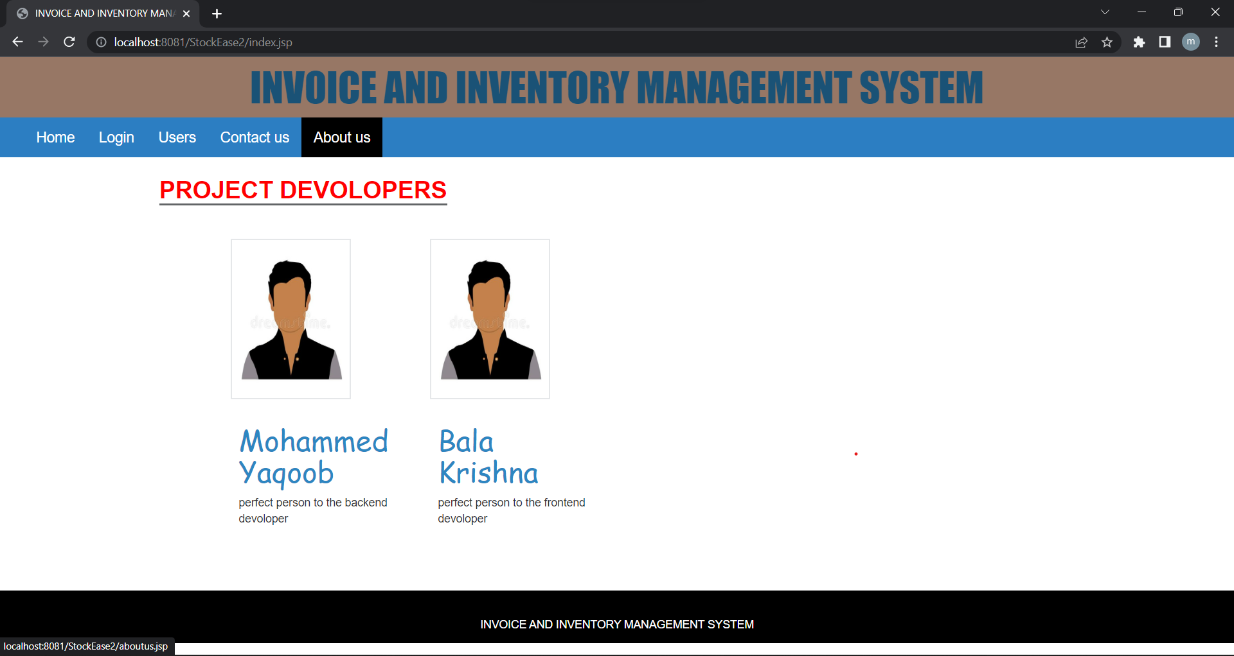

Figure 3.1:

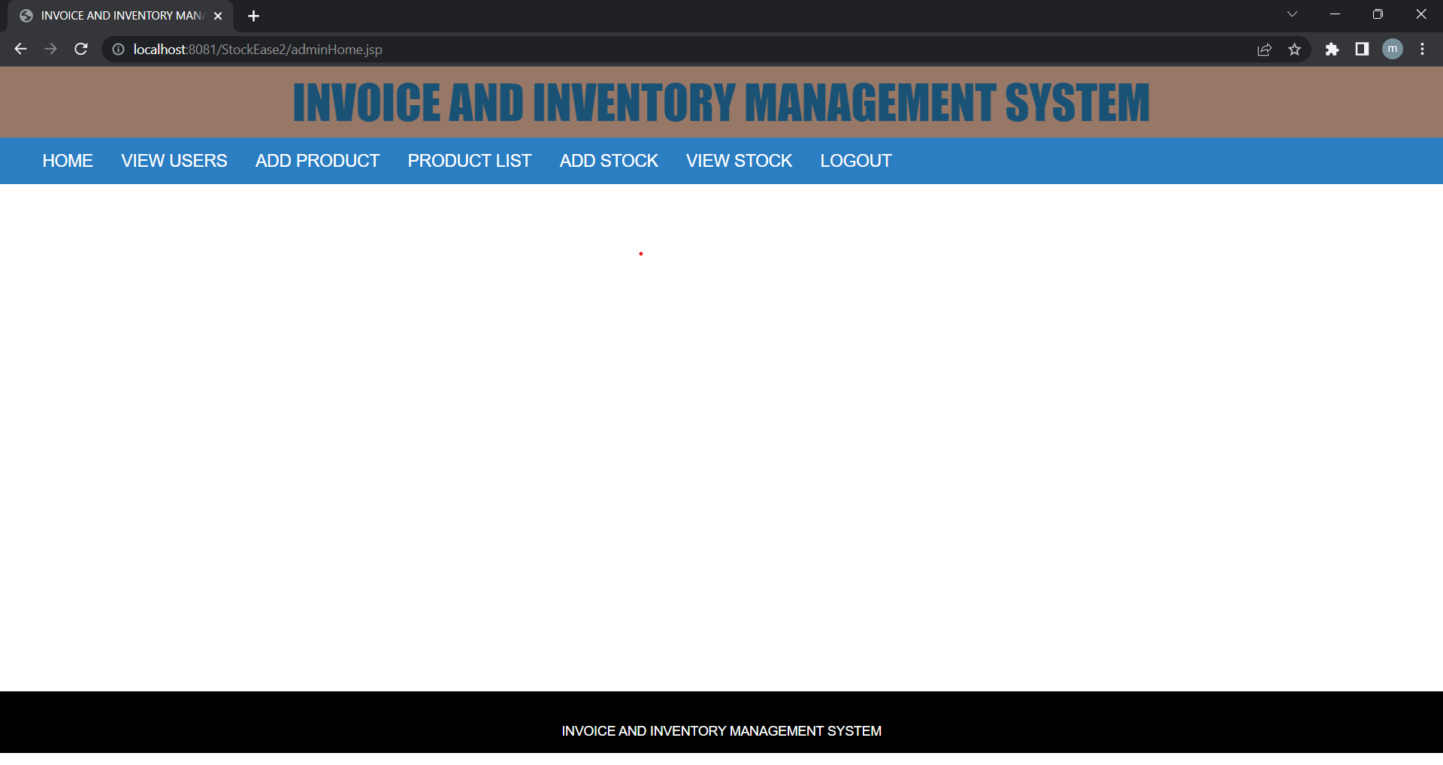

Figure 3.2:

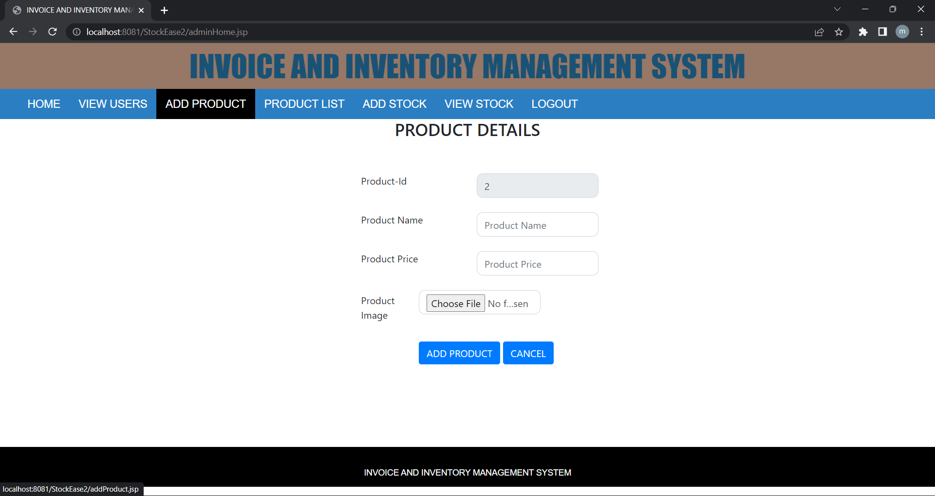

Figure 3.3:

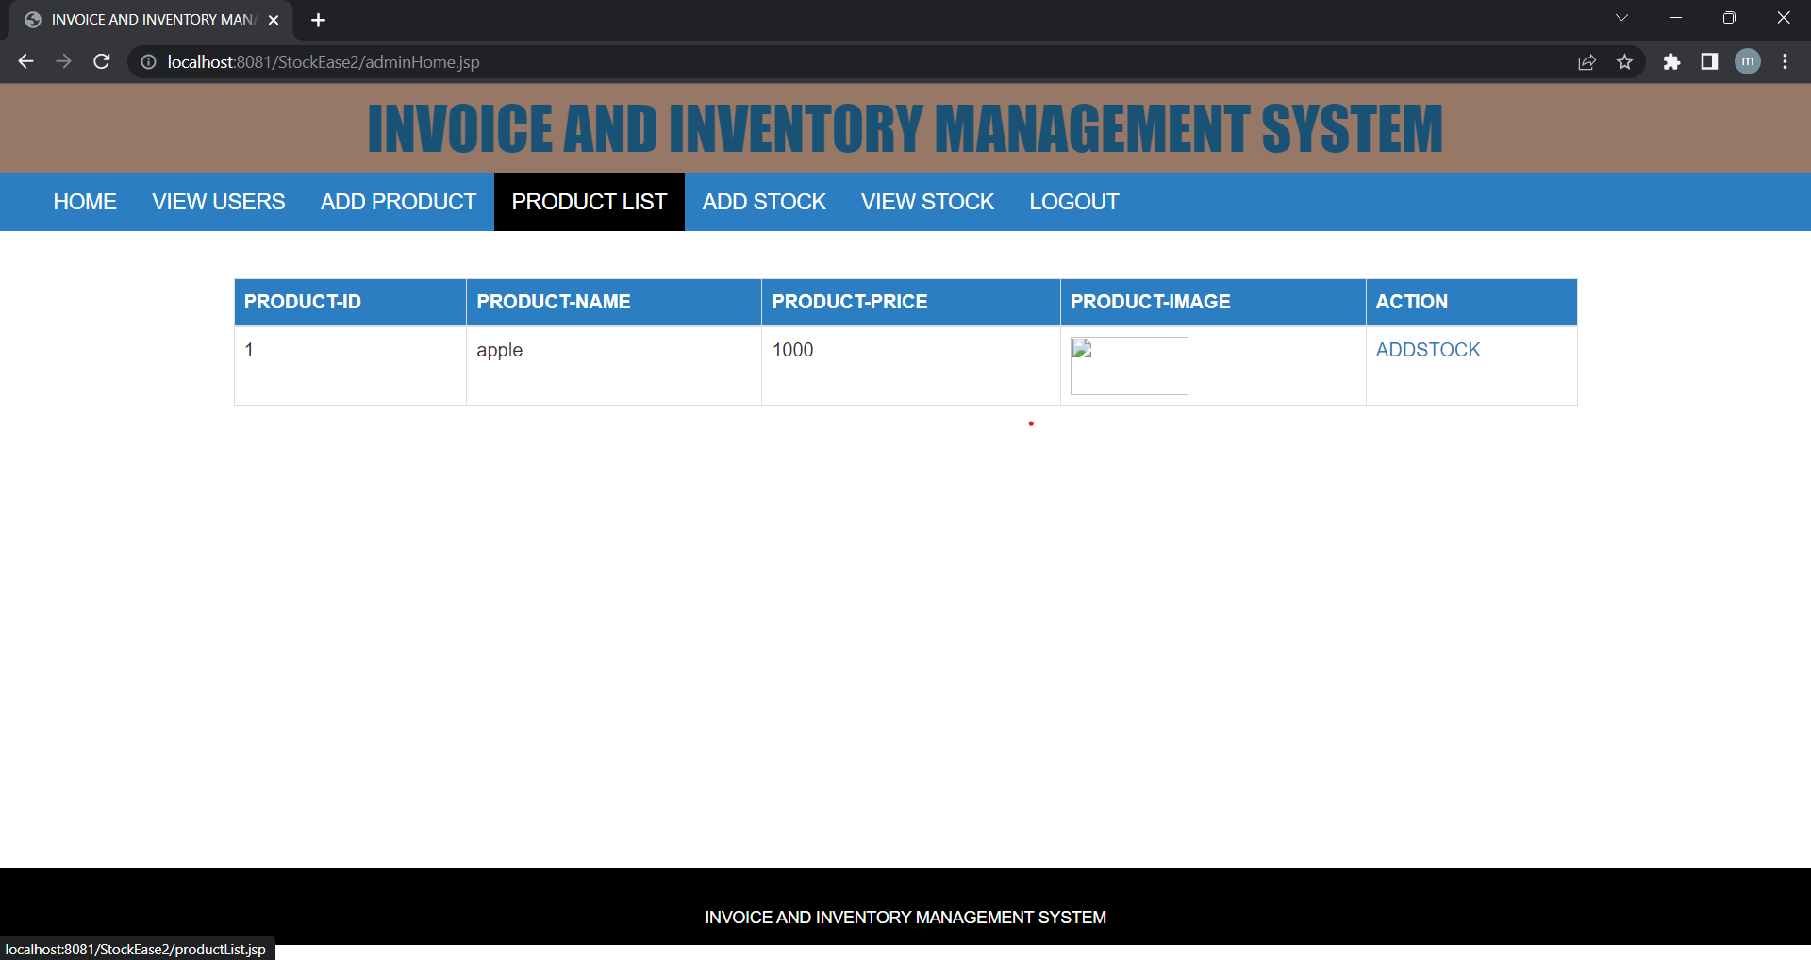

Figure 3.4:

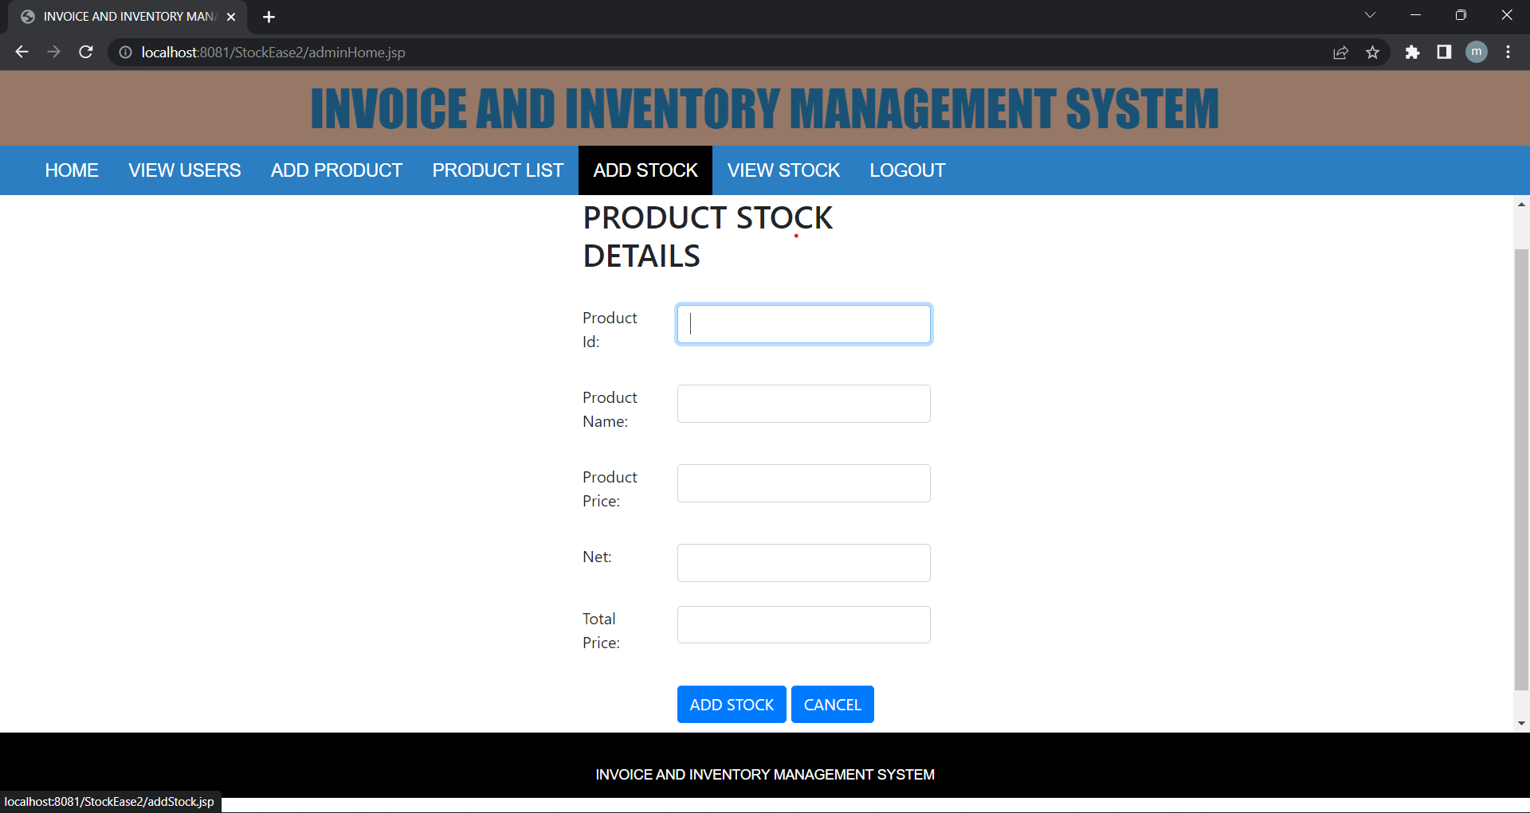

Figure 4.1:

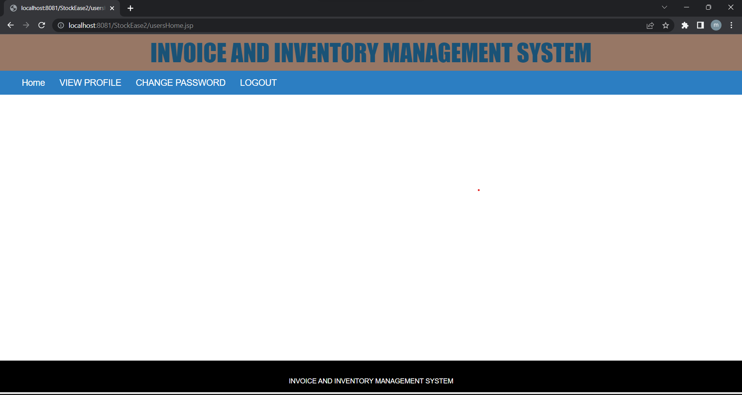

Figure 4.2:

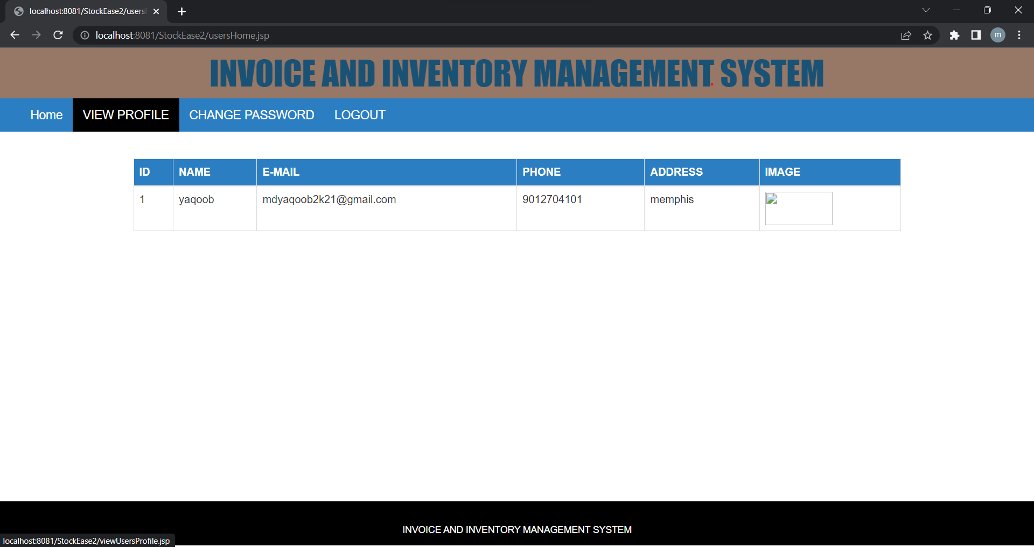

Figure 4.3:

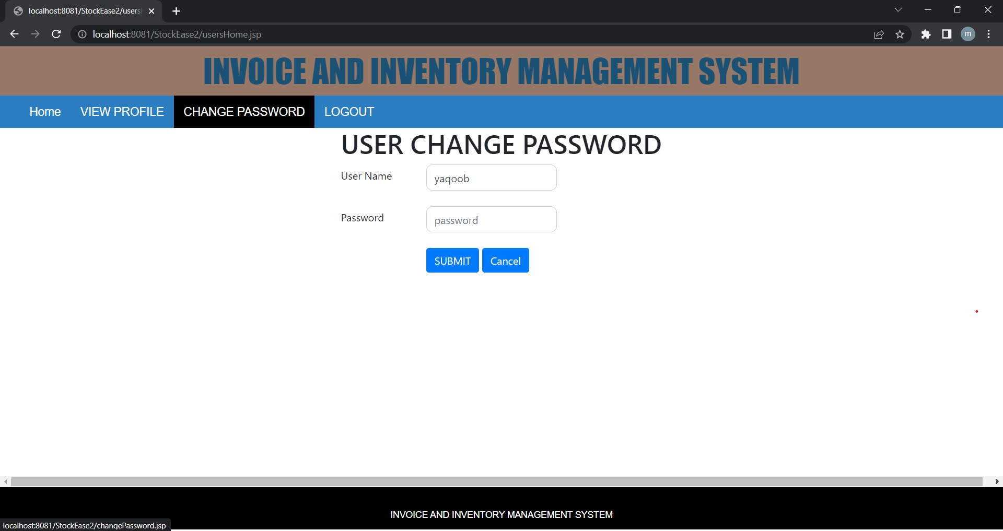

# 3.FUTURE PLANS

In Future we are going to add a functionality to search for products and also, we will add a functionality to generate invoices. We are going to add the features as per the requirement of the projects. Later we may see more functionalities in this application.